Logicbroker

Version 20.1.0



Table of Contents
1. Summary 3
2. Component Overview 4-6
2.1 Functional Overview 4
Logicbroker custom job steps 4
2.2 Use Case 5
2.3 Limitations, Constraints 5
2.4 Compatibility 6
2.5 Privacy, Payment 6
3. Implementation Guide 7-11
3.1 Setup 7
Upload the cartridge 7
Add cartridge to site path 7
Add cartridge to Business Manager path 7
Import metadata 8
3.2 Business Manager Configuration 8
Configure logging 8
Configure Logicbroker credentials 8
Configure job scopes 9
Configure job schedules 11
3.3 External Interfaces 12
3.4 Firewall Requirements 12
3.5 Testing 12
4. Operations, Maintenance 13
4.1 Data Storage 13
4.2 Availability 13
4.3 Support 13
5. User Guide 14-17
5.1 Roles, Responsibilities 14
5.2 Business Manager 14
Logicbroker Export Orders 14
Logicbroker Pull Acknowledgements 15
Logicbroker Pull Shipments 15
Logicbroker Pull Inventory 16
Logicbroker Create Matching Template 17
5.3 Storefront Functionality 18
6. Known Issues 19
7. Release History 20

Summary

Logicbroker provides EDI and drop ship technology that unites brands, retailers, and the systems they rely on. We provide retailers with modern technology to grow, manage, and simplify your drop ship program. Our fast and flexible options with unrivaled support enable seamless communication between the house, vendors and 3PLS.

This LINK cartridge enables Commerce Cloud customers to integrate with Logicbroker’s platform through scheduled jobs and features the following capabilities:
- Send orders directly to the Logicbroker system automatically
- Pull shipments from Logicbroker into Commerce Cloud and automatically update tracking numbers
- Pull acknowledgements from Logicbroker in the form of order notes
- Import inventory quantity updates from Logicbroker and update in Commerce Cloud
- Download a template for creating a matching file
This document will guide you through the process of integrating Logicbroker with your Commerce Cloud environment. In order to take advantage of these features, you will need to have a Logicbroker account. For more information or to sign up, visit https://www.logicbroker.com/.

Component Overview

Functional Overview

This cartridge is meant to be used in conjunction with a Logicbroker account to integrate the drop ship automation services of Logicbroker seamlessly with the B2C Commerce platform.
The Logicbroker LINK cartridge includes the following features in Business Manager:
- A storefront-level credentials configuration page
- Preloaded import/export jobs that require only basic configuration before use
It is designed to work for either a SiteGenesis or Storefront Reference Architecture (SFRA) site.

Logicbroker custom job steps
The cartridge uses the following custom job steps to integrate with Logicbroker. For more detail about their usage, see Section 5.2 of this document.

Job Step: custom.Logicbroker.SendOrders
Preloaded Job: Logicbroker Export Orders
Function: Looks for orders that are status New/Open and Ready to Export, and exports them to Logicbroker.
Updates: Updates order status to Exported, adds Logicbroker Key to shipment attributes.
On Failure: Export status Failed, adds order note with the error message.

Job Step: custom.Logicbroker.PullShipments
Preloaded Job: Logicbroker Pull Shipments
Function: Imports shipments from Logicbroker in status 100 (Submitted).
Updates: Updates tracking number on the Commerce Cloud shipment, creates order note with all tracking information. Updates shipment status to Shipped, updates order status to Partially Shipped or Shipped, depending on if all shipments have been marked as shipped.
On Failure: Error details can be found in custom Logicbroker log file.

Job Step: custom.Logicbroker.PullAcks
Preloaded Job: Logicbroker Pull Acknowledgements
Function: Imports acknowledgements from Logicbroker in status 100 (Submitted).
Updates: Creates order note with acknowledgement information.
On Failure: Error details can be found in custom Logicbroker log file.

Job Step: custom.Logicbroker.PullInventory
Preloaded Job: Logicbroker Pull Inventory
Function: Imports inventory quantity updates from all connected partners in Logicbroker into the inventory associated with the Commerce Cloud site in the job scope.
Updates: Updates inventory records with new quantity, creates/updates inventory history file found under IMPEX/src/logicbroker/inventoryHistory/<Site Name> (for internal use only).
On Failure: Error details can be found in custom Logicbroker log file.

Job Step: custom.Logicbroker.DownloadMatchingTemplate
Preloaded Job: Logicbroker Create Matching Template
Function: Provides a downloadable template for creating a matching file. It will contain the following headers: SupplierSKU (blank, to be filled in after download), MerchantSKU, UPC, ManufacturerSKU, Description.
Updates: Creates a file under IMPEX/src/logicbroker/matchingTemplates which can then be downloaded by the user.
On Failure: Error details can be found in custom Logicbroker log file.

Use Case

A customer places an order on the storefront. This order is split (by Commerce Cloud) into shipments by shipping address. The Logicbroker Send Orders job will export any Open/New orders that are Ready to Export, exporting each shipment separately as its own order. From Logicbroker, the order is sent out to the appropriate 3PL, warehouse fulfillment, or dropship suppliers. When Logicbroker gets a shipment, the Logicbroker Pull Shipments job will pull the tracking information into Commerce Cloud and mark the shipment/order as shipped. If your trading partners support sending acknowledgements when orders are received, the Logicbroker Pull Acknowledgements job will add a note to the order with that information.

Limitations, Constraints

Pull Shipments:
- It is not the responsibility of Logicbroker to notify a customer when their order has shipped.
- Logicbroker will mark a shipment as Shipped regardless of exactly which items were present on the shipment.
- Commerce Cloud only allows space for one tracking number per shipment, however, to accommodate partial shipments, any additional tracking numbers will be listed on an order note.
Pull Acknowledgements:
- Acknowledgements do not affect the shipments or items directly; only an order note is added.

Compatibility

Tested against Commerce Cloud version 21.2
Compatibility mode 19.10
Only available in English

Privacy, Payment

The Logicbroker LINK cartridge does not process or store payment information or customer profile data.

Implementation Guide

Setup

Upload the cartridge
Using your preferred method, upload the int_logicbroker cartridge to your server. If you have Eclipse connected to your server, then the easiest way is to import the int_logicbroker folder into your UX Studio workspace (File > Import > General > Existing Projects into Workspace) and attach it to your Digital Server.

Add cartridge to site path
For every site that you want to connect, navigate to Administration > Sites > Manage Sites, select the site, and under Settings, add “:int_logicbroker” to the end of the cartridge path. Click Apply to save your changes.
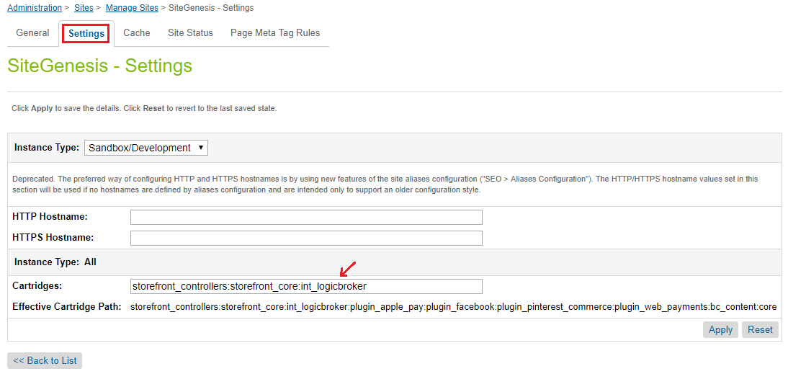

Add cartridge to Business Manager path
For every site that you want to connect, navigate to Administration > Sites > Manage Sites. Under Business Manager Site, select “Manage the Business Manager site”. Under Settings, add “:int_logicbroker” to the end of the path. Click Apply to save your changes.
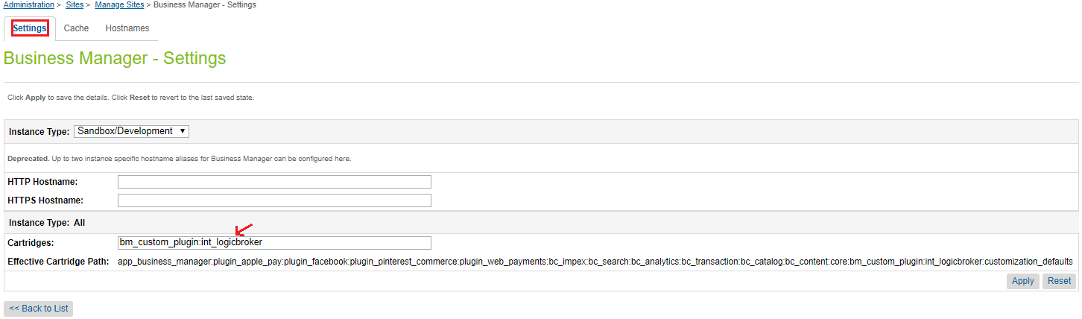

Import metadata
Navigate to the metadata folder of the cartridge and zip it. The file structure should be as follows:
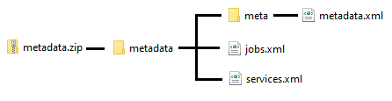

In Business Manager, navigate to Administration > Site Development > Site Import & Export.

Under Import, select Choose File and upload metadata.zip. Click to upload the file.
Then below, select the newly uploaded metadata.zip file and click Import. Confirm the import.

Business Manager Configuration

Configure logging
Navigate to Administration > Operations > Custom Log Settings.
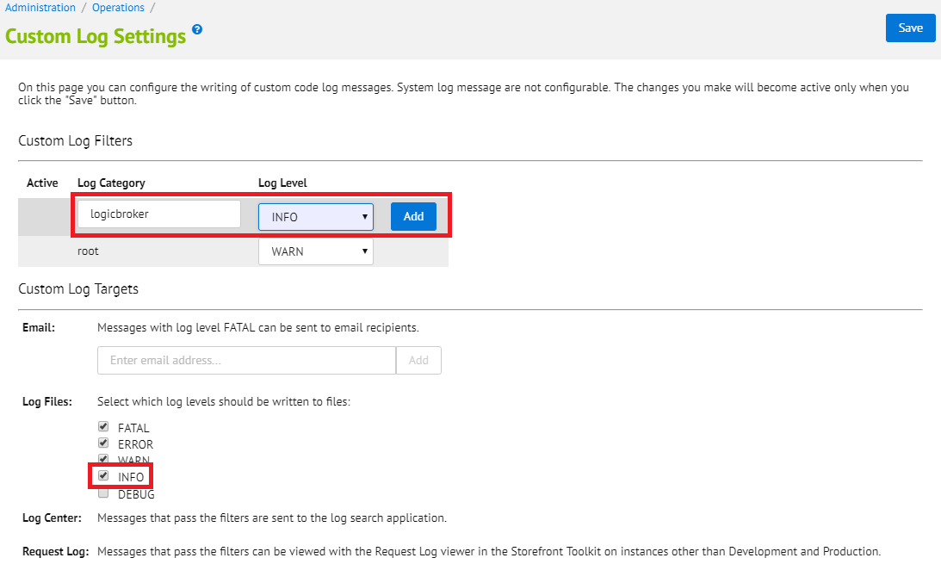
Add “logicbroker” as a log category with log level INFO. Under Log Files, check INFO if it is not already checked.

Configure Logicbroker credentials
For every site that you want to connect, navigate to Merchant Tools > Site Preferences > Custom Preferences. You should see a Preference Group called Logicbroker. If you do not, check that you uploaded the metadata.xml file correctly in Section 3.1.
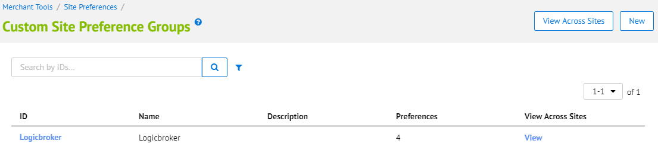

Select “Logicbroker” to bring you to the Logicbroker configuration page.
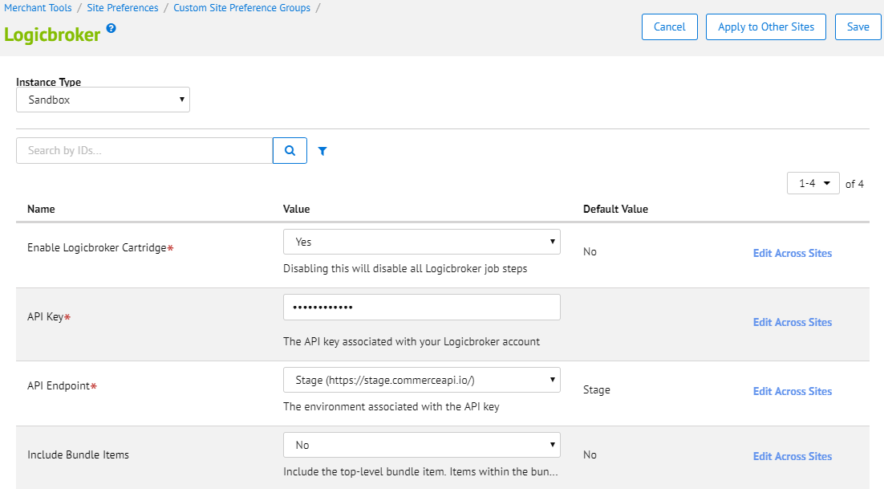

Please configure the fields with the following information:
- Enable Logicbroker Cartridge: Switch this to Yes to enable the cartridge. If it is not enabled, the jobs will NOT run, even if they are listed as enabled.
- API Key: Enter your Logicbroker API key. There are different API keys for the staging and production Logicbroker environments. These are separate from the Commerce Cloud server instance types.
- API Endpoint: Select whether the API key is associated with the stage or production endpoint. The API key and endpoint can be found in the Logicbroker portal.
- Include Bundle Items: When Yes, Logicbroker will import the top-level bundle item on the order, along with all of the bundled items. By default, this value is No. Items within the bundle are always included.

Configure job scopes
Navigate to Administration > Operations > Job Schedules. You should see five pre-loaded Logicbroker jobs. If you do not, check that you uploaded the jobs.xml file correctly in Section 3.1.
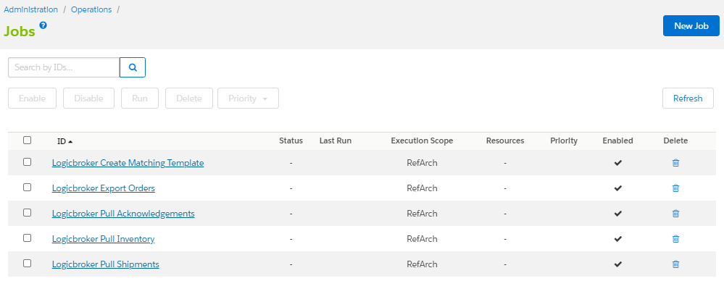
All five of the jobs come enabled but require a small amount of configuration before they will run. If your trading partners do not support sending acknowledgements, you can use the trash button to delete Logicbroker Pull Acknowledgements. If you do not need to download matching file templates, you can use the trash button to delete Logicbroker Create Matching Template.

For each of the jobs, adjust the job scope as needed. Click on each job and select the Job Steps tab. Then click where it says the scope is RefArch.
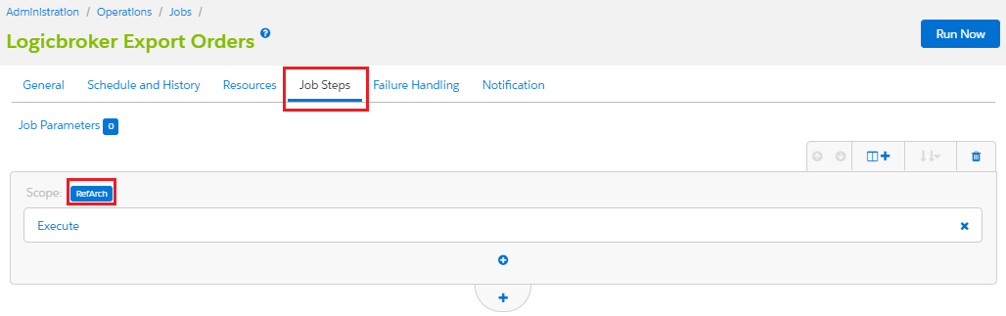
Check off all the sites which will be connected to Logicbroker. Then click Assign.
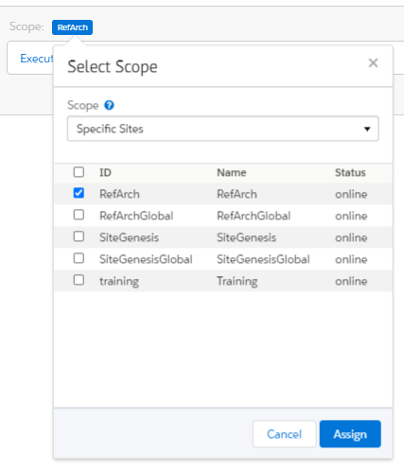

Configure job schedules
The inventory job comes preconfigured to run every hour, and the orders, shipments, and acknowledgements jobs come preconfigured to run every 15 minutes. However, these are entirely customizable by selecting the Schedule and History tab of the job. You can change the recurring intervals on a per-job basis to suit your business needs. The matching template job is not scheduled, and must be manually run unless otherwise configured.
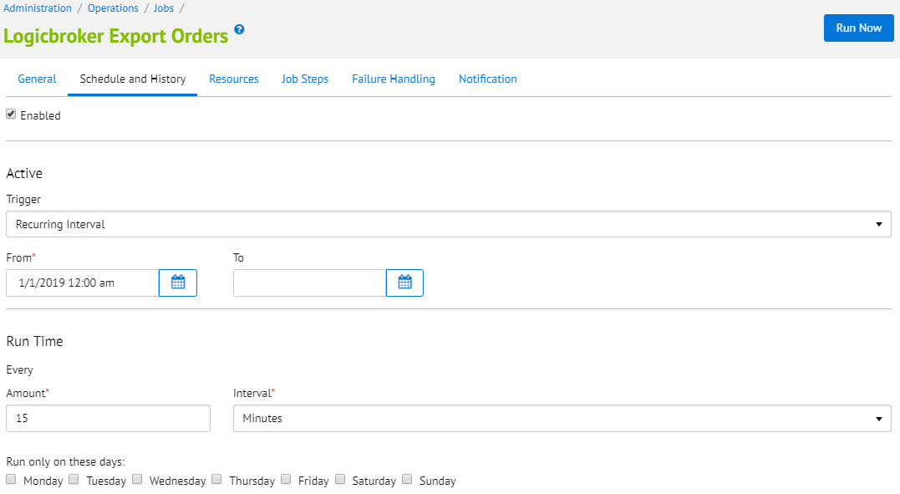

External Interfaces

This cartridge makes several external calls to Logicbroker API endpoints using Web Services and the API key/endpoint set in the site’s configuration page. All calls are integral to the cartridge’s functionality. The service is called LogicbrokerService and can be found under Administration > Operations > Services.

Firewall Requirements

No firewall changes are required.

Testing

All Logicbroker customers will have access to a stage environment. Logicbroker will assist with the testing process to ensure that the connection is set up properly and functional. In addition, there are test cases provided with this cartridge to test the basic cartridge functionality.

Operations, Maintenance

Data Storage

The Logicbroker cartridge creates a custom attribute on Shipment objects to store the Logicbroker key associated with the shipment within Commerce Cloud. It also stores your Logicbroker API key on the configuration page.

All orders sent to Logicbroker will be stored in our system.

Availability

Logicbroker strives to provide consistent service to its customers. As such, Logicbroker services can be expected to have 99.95% uptime. If you are experiencing problems, please contact support.

Support

In case of an issue, Logicbroker will do everything possible to get everything back to running smoothly. Please contact support@logicbroker.com with any concerns.

User Guide

Roles, Responsibilities

It is the responsibility of the site to note any failed exports of orders. Logicbroker will not monitor if an order has not made it into the system.

Under normal functioning circumstances, there are no manual responsibilities beyond setup and configuration.

Business Manager

This section is meant to show cartridge usage after it has already been configured as described in Section 3.

Logicbroker Export Orders
Once an order has been placed on the SFCC storefront, it will be in Ready to Export status. After running the Logicbroker Export Orders job, the export status will update to Exported.

An order note will be created by the job, indicating that it was successful.

The job exports each shipment on an order as a separate order. Because of this, each shipment will get its own Logicbroker key. This can be found on the shipment’s details page, on the Attributes tab.
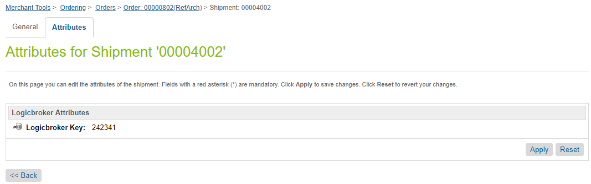

Error Messages:
In the case of trying to export an order that has already been exported, there will be an error message in the notes indicating that the order is already in the Logicbroker system. The export status will be set back to Exported.

In the case of a transmission error, an order note will be created showing the error message. A more comprehensive error message can be found in the Logicbroker log file. The export status will be set to Export Failed.

Logicbroker Pull Acknowledgements
Note: This section is only relevant if your trading partners support sending acknowledgements in response to orders.

When Logicbroker receives an acknowledgement, it will be pulled into Commerce Cloud next time the Logicbroker Pull Acknowledgements job runs. An order note will be created showing product IDs and the corresponding quantity accepted, cancelled, or backordered.
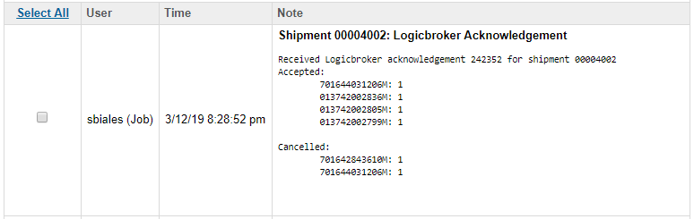

Error Messages:
In case of an error importing an acknowledgement (i.e. the job cannot find the order/shipment associated with the acknowledgement) an error message will be created in the log.

Logicbroker Pull Shipments
When the job pulls a shipment from the Logicbroker system into Commerce Cloud, the shipment’s shipping status is set to Shipped. In addition, the first tracking number found will be recorded in the Tracking Number field.
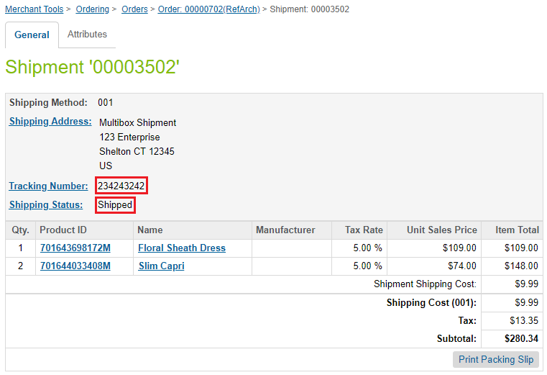

However, some shipments may ship in multiple boxes. To accommodate this, an order note will also be created with all tracking information from the shipment.
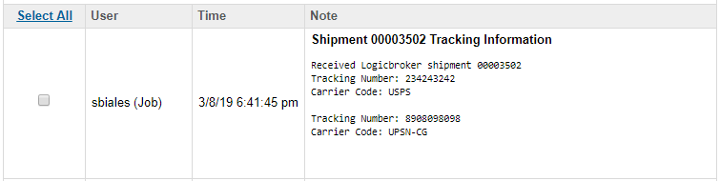

The job will also update the order shipping status. If only some of the order shipments have shipped, the order’s shipping status will be updated to Partially Shipped. Once all shipments have been shipped, it will be updated to Shipped.
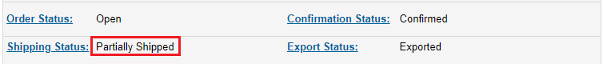

Error Messages:
In case of an error importing a shipment (i.e. the job cannot find the order/shipment associated with the Logicbroker shipment) an error message will be created in the log.

Logicbroker Pull Inventory
The Logicbroker Pull Inventory job pulls any updated inventory quantities from Logicbroker and updates the respective inventory records in Commerce Cloud. The inventory list it looks at is the list assigned to the site in the job’s scope. It will set the allocation on the product.
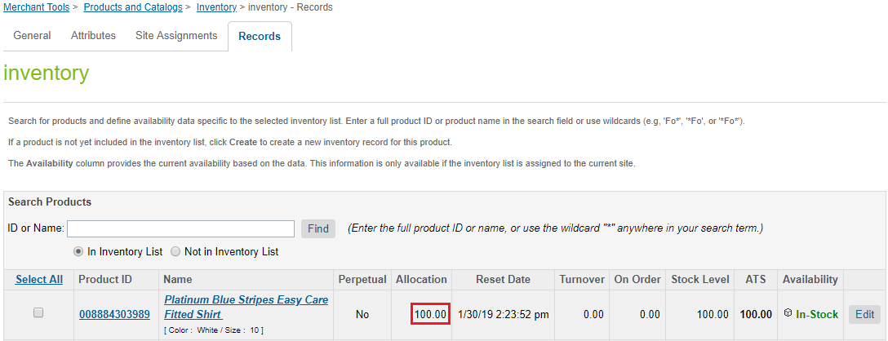

The process will create a small history file under IMPEX/src/logicbroker/inventoryHistory/<Site Name> so that it only pulls items that have been updated since the last time the job ran.

In addition, the job will create an inventory report as an event viewable from the Logicbroker Portal. It contains a downloadable file with all updated product IDs, their previous quantities, and their updated quantities.
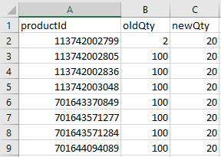

Error Messages:
If the job fails at any point, it will create an error message in the Logicbroker log describing the failure.

Logicbroker Create Matching Template
This job offers additional functionality beyond the four scheduled jobs. It can be used to facilitate the creation of a matching file, to match Supplier SKU to Merchant SKU. If you do not need this functionality, you can choose to delete this job, or never enable/trigger it.

To use this job, you must manually trigger it. Click on the job and press the Run Now button to generate the matching file template. Once the job has run, you can find the newly generated files under IMPEX/src/logicbroker/matchingTemplates. From Business Manager, navigate to Administration > Site Development > Development Setup. Under WebDAV Access, click on the link under Import/Export. From there you can navigate to the files and click to download them.
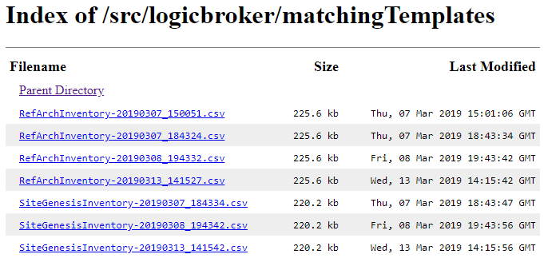

Once it has been downloaded, open the file, fill in the Supplier SKUs, and upload it to the Logicbroker Portal.
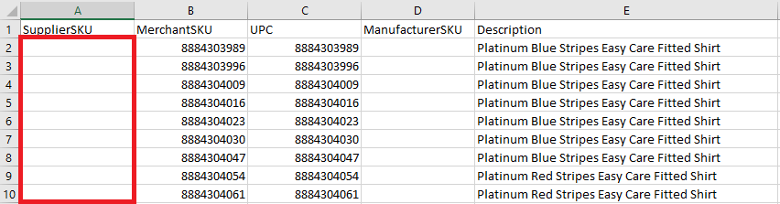

Error Messages:
If the job fails, an error message will be written to the Logicbroker log file.

Storefront Functionality

The Logicbroker cartridge does not alter the storefront in any way.

Known Issues

There are no known issues at this time.

Release History

Version | Date | Changes
19.1.0 | April 1, 2019 | Initial release
19.1.1 | August 5, 2019 | Fixed error logging messages and failed events
19.1.2 | January 7, 2020 | Add support for import/export of custom attributes
20.1.0 | July 22, 2020 | Use site import/export, fix Logicbroker Service
21.1.0 | February 4, 2021 | Prevent export of itemless orders, fix Logicbroker Service

