Logicbroker Test Cases
  - For SFCC SiteGenesis or SFRA sites

The purpose of this document is to provide walkthroughs to test the functionality of the cartridge after setup.

Prerequisites:
- You have gone through the cartridge setup and configuration process outlined in the Logicbroker Integration Documentation
- You have Logicbroker Portal credentials
- You have generated a Logicbroker API key for the stage (testing) environment
- Your site is connected to an inventory in Commerce Cloud

Verify installation

After completing set up instructions, verify the following in Business Manager before beginning testing:
- Verify Metadata Import
Under Merchant Tools > Site Preferences > Custom Preferences, there is a Logicbroker preference group. Ensure that you have entered your Logicbroker Stage API key, the endpoint is set to “Stage”, and Enable Logicbroker Cartridge is set to “Yes”.
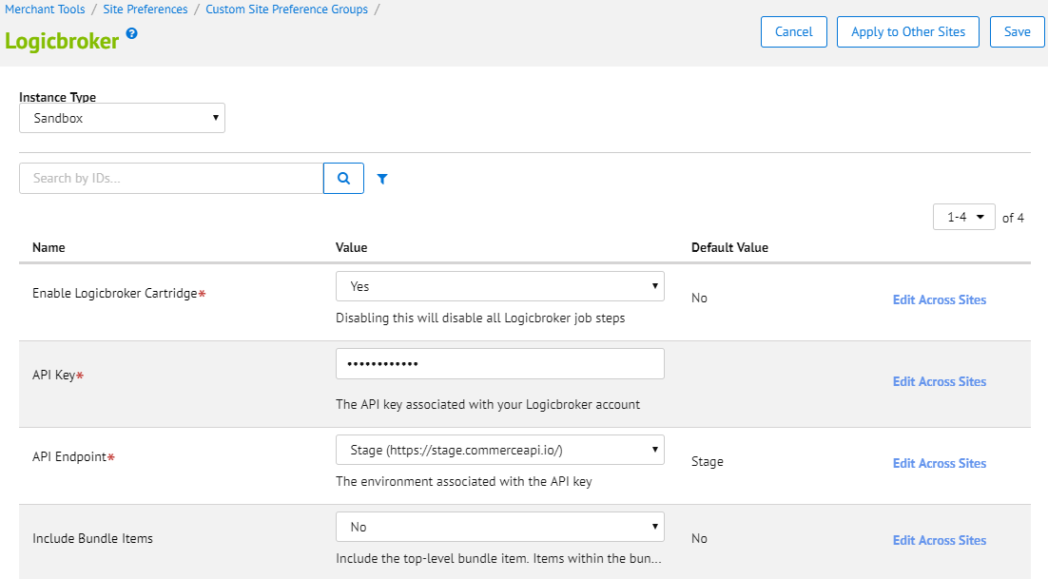
Note: For help finding/generating your API key, see this help article.
- Verify Jobs Import
Under Administration > Operations > Job Schedules, verify that you see all five Logicbroker jobs. Verify that the execution scope is set to at least one site, and that all jobs have been enabled. You can test more than one site simultaneously by setting the scope to multiple sites.
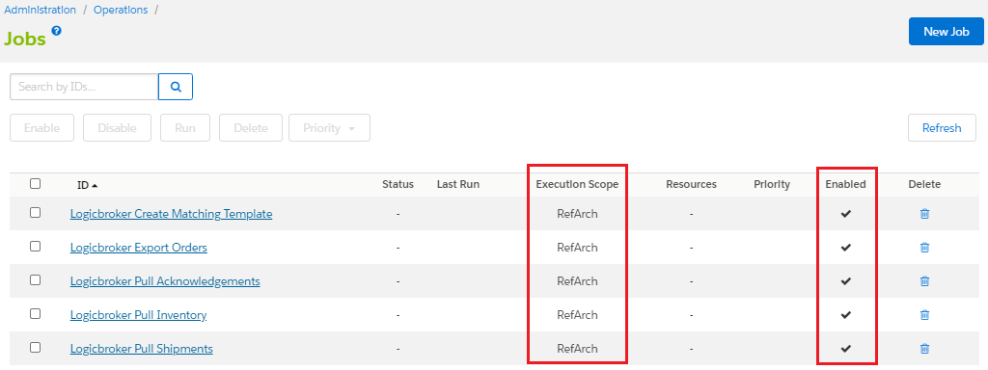

Test Case 1: Download Matching File Template, Upload to Logicbroker (No Top-Level Bundle Items)

Prerequisites:
In the Logicbroker configuration in Business Manager, set Include Bundle Items to “No”.

Test steps:
- From Business Manager, navigate to Administration > Operations > Jobs and run the Logicbroker Create Matching Template job to create the matching file template.
- Once it has completed running (this should be almost instantaneous), navigate to Administration > Site Development > Development Setup. Under WebDav Access, open the link under Import/Export.
- Once in the IMPEX directory, navigate to src/logicbroker/matchingTemplates and find the matching file that was just created.
- Click the file to download it.
- Once downloaded, open the file using your preferred method. If you are using Excel, be sure that no numbers are cut off the front of the SKUs. If that is happening, you will have to import the csv data into an empty Excel spreadsheet from the Data ribbon.
- Fill in the Supplier SKU with the correct values (if testing only, it is sufficient to copy over the values from the Merchant SKU column) and save the file.
- Navigate to the Logicbroker Portal > Products > Inventory Feeds.
- Upload the file, and select Matching File as the type.
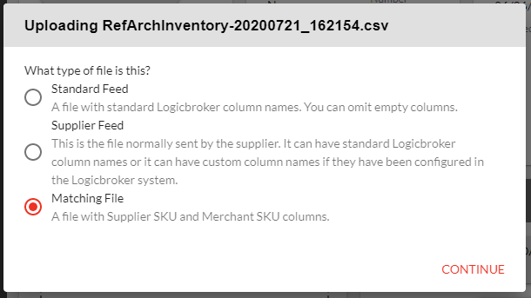

Verification:
- In the Logicbroker Portal, navigate to Products > Inventory Search. Verify that the upload was successful by noting that Supplier SKU and Merchant SKU are populated.
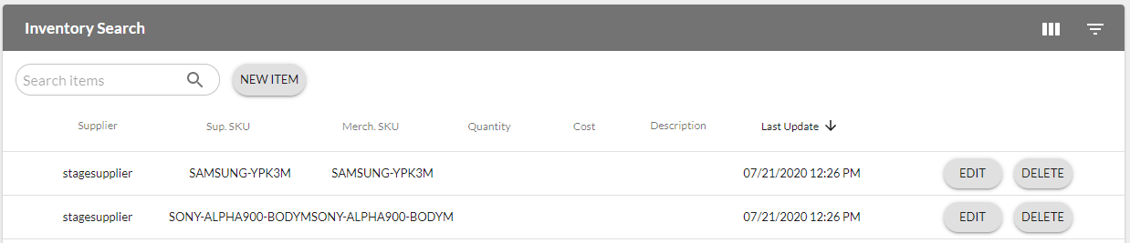
- In Business Manager, take note of a bundle item’s product ID (if the site’s inventory includes bundle items).
- In Logicbroker’s Inventory Search, verify that the bundle item’s product ID is not imported.

Test Case 2: Download Matching File Template, Upload to Logicbroker (Include Top-Level Bundle Items)

Prerequisites:
The site’s inventory includes at least one bundle item.
In the Logicbroker configuration in Business Manager, set Include Bundle Items to “Yes”.

Test steps:
- From Business Manager, navigate to Administration > Operations > Jobs and run the Logicbroker Create Matching Template job to create the matching file template.
- Once it has completed running (this should be almost instantaneous), navigate to Administration > Site Development > Development Setup. Under WebDav Access, open the link under Import/Export.
- Once in the IMPEX directory, navigate to src/logicbroker/matchingTemplates and find the matching file that was just created.
- Click the file to download it.
- Once downloaded, open the file using your preferred method. If you are using Excel, be sure that no numbers are cut off the front of the SKUs. If that is happening, you will have to import the csv data into an empty Excel spreadsheet from the Data ribbon.
- Fill in the Supplier SKU with the correct values (if testing only, it is sufficient to copy over the values from the Merchant SKU column) and save the file.
- Navigate to the Logicbroker Portal > Products > Inventory Feeds.
- Upload the file, and select Matching File as the type.

Verification:
- In the Logicbroker Portal, navigate to Products > Inventory Search. Verify that the upload was successful by noting that Supplier SKU and Merchant SKU are populated.
- In Business Manager, take note of a bundle item’s product ID.
- In Logicbroker’s Inventory Search, verify that the bundle item’s product ID is there.

Test Case 3: Pull Inventory

Prerequisites:
You have uploaded inventory to Logicbroker.

Test steps:
- In Business Manager, navigate to Merchant Tools > Products and Catalogs > Inventory and select the inventory associated with the site being tested.
- Navigate to the Records tab and note one product’s Product ID and current Allocation.
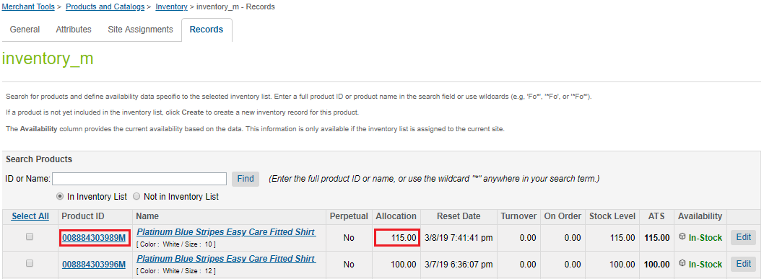
- In the Logicbroker Portal, navigate to Products > Inventory Search.
- Search for the Product ID that you noted to locate the product in Logicbroker’s system.
- Edit the product’s quantity to something other than the current Allocation and click Save.
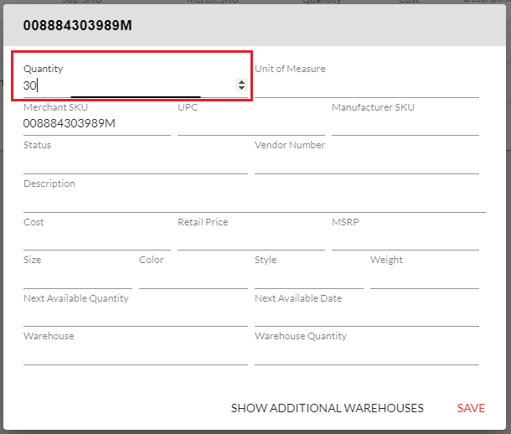
- Return to Business Manager and navigate to Administration > Operations > Jobs.
- Run the Logicbroker Pull Inventory job.

Verification:
- In Business Manager, navigate back to Merchant Tools > Inventory and select the inventory associated with the site being tested.
- On the Records tab, search for the Product ID of the product that was edited.
- Verify that the Allocation field now reflects the change that was made in the Logicbroker Portal.

Test Case 4: Export Multi-line Order (No Top-level Bundle Items, One Ship Address)

Prerequisites:
In the Logicbroker configuration in Business Manager, set Include Bundle Items to “No”.

Test steps:
- In your storefront, place an order containing multiple products. If your store sells bundled items, include one in your test order. Ship to only one address. Set a gift message.
- Return to Business Manager and navigate to Administration > Operations > Jobs.
- Run the Logicbroker Export Orders job.

Verification:
- In the Logicbroker portal, verify that the purchase order is now there (The order number will be of the format [SFCC Order Number]-[SFCC Shipment Number]). If it was successful, it will be in Ready to Ship status. If there was an issue, it will be in Failed.
- Click View to verify all line items are there, excluding the top-level bundle item. If you typed in a gift message, it will appear under Notes.
- In Business Manager, navigate to Merchant Tools > Ordering > Orders and find the newly placed order.
- Verify that the order’s Export Status now says “Exported” but the Shipping Status still says “Not Shipped”.
- Click on the shipment and navigate to the Attributes tab. Verify that there is now a Logicbroker Key attribute matching the ID number of the order in the Logicbroker Portal.
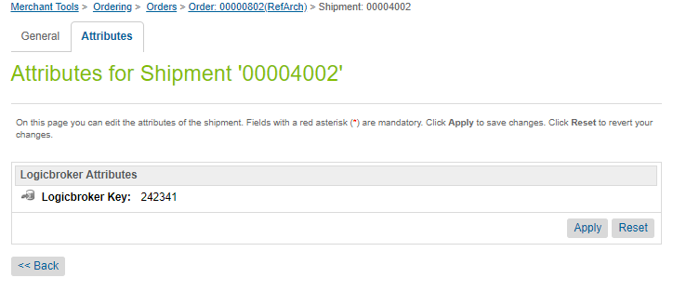

Test case 5: Export Order (Include Top-Level Bundle Items, One Ship Address)

Prerequisites:
In the Logicbroker configuration in Business Manager, set Include Bundle Items to “Yes”.
Inventory must contain at least one bundled item (if it does not, skip this test case).

Test steps:
- In your storefront, place an order containing a bundled item. Ship to only one address.
- Return to Business Manager and navigate to Administration > Operations > Jobs.
- Run the Logicbroker Export Orders job.

Verification:
- In the Logicbroker portal, verify that the purchase order is now there (The order number will be of the format [SFCC Order Number]-[SFCC Shipment Number]). If it was successful, it will be in Ready to Ship status. If there was an issue, it will be in Failed.
- Click View to verify all line items are there, including the top-level bundle item.
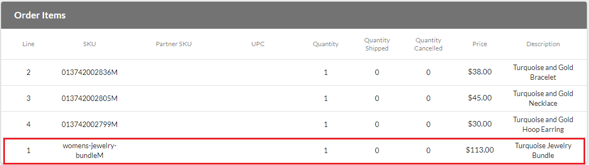
- In Business Manager, navigate to Merchant Tools > Ordering > Orders and find the newly placed order.
- Verify that the order’s Export Status now says “Exported” but the Shipping Status still says “Not Shipped”.
- Click on the shipment and navigate to the Attributes tab. Verify that there is now a Logicbroker Key attribute matching the ID number of the order in the Logicbroker Portal.

Test Case 6: Export Order (Multiple Ship Addresses)

Prerequisites:
N/A

Test steps:
- In your storefront, place an order containing multiple products. When checking out, ship the items to at least 2 different addresses.
- Return to Business Manager and navigate to Administration > Operations > Jobs.
- Run the Logicbroker Export Orders job.

Verification:
- In the Logicbroker portal, verify that there is now a purchase order for each shipping address (The order number will be of the format [SFCC Order Number]-[SFCC Shipment Number]). If it was successful, it will be in Ready to Ship status. If there was an issue, it will be in Failed.
- In Business Manager, navigate to Merchant Tools > Ordering > Orders and find the newly placed order.
- Verify that the order’s Export Status now says “Exported” but the Shipping Status still says “Not Shipped”.
- Click on each shipment and navigate to the Attributes tab. Verify that there is now a Logicbroker Key attribute matching the ID number of the corresponding order in the Logicbroker Portal for each of the shipments.

Test Case 7: Pull Acknowledgements (Accept/Cancel Items)

Prerequisites:
Create an order with at least 2 items and export it to Logicbroker.

Test steps:
- Create an acknowledgement in Logicbroker that accepts at least one line item and cancels at least one line item.
- Return to Business Manager and navigate to Administration > Operations > Jobs.
- Run the Logicbroker Pull Acknowledgements job.

Verification:
- In Business Manager, navigate to Merchant Tools > Ordering > Orders and find the order associated with the acknowledgement.
- Navigate to the Notes tab on the order.
- Verify that there is a new order note containing the information from the acknowledgement.
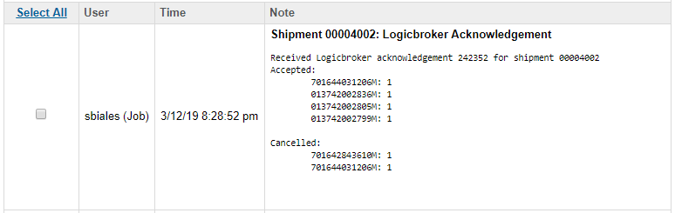

Test Case 8: Pull Acknowledgements (Backorder Items)

Prerequisites:
Create an order and export it to Logicbroker.

Test steps:
- Create an acknowledgement in Logicbroker that backorders all items on the order.
- Return to Business Manager and navigate to Administration > Operations > Jobs.
- Run the Logicbroker Pull Acknowledgements job.

Verification:
- In Business Manager, navigate to Merchant Tools > Ordering > Orders and find the order associated with the acknowledgement.
- Navigate to the Notes tab on the order.
- Verify that there is a new order note containing the information from the acknowledgement.
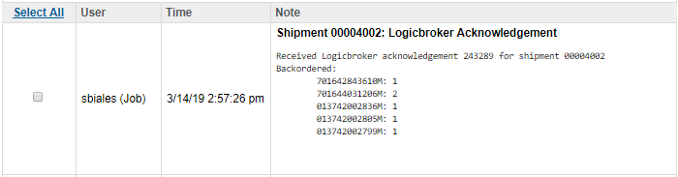

Test Case 9: Pull Shipments (Multiple Ship Addresses, Partially Shipped)
This test will partially ship a SFCC order (Fully ship a single order in Logicbroker)

Prerequisites:
Create an order that ships to at least 2 different addresses and export it to Logicbroker.

Test steps:
- In the Logicbroker Portal, find ONE of the orders associated with the SFCC order you created.
- Create a shipment in Logicbroker for this order and ship all line items, providing a carrier code and tracking number.
- Return to Business Manager and navigate to Administration > Operations > Jobs.
- Run the Logicbroker Pull Shipments job.

Verification:
- In Business Manager, navigate to Merchant Tools > Ordering > Orders and find the order associated with the shipment.
- Verify that the order’s Shipping Status is “Partially Shipped”.
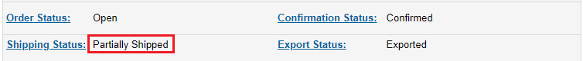
- Click on the shipment that should have been shipped.
- Verify there is a tracking number which matches the one entered in the Logicbroker system, and that the shipment’s Shipping Status is “Shipped”.
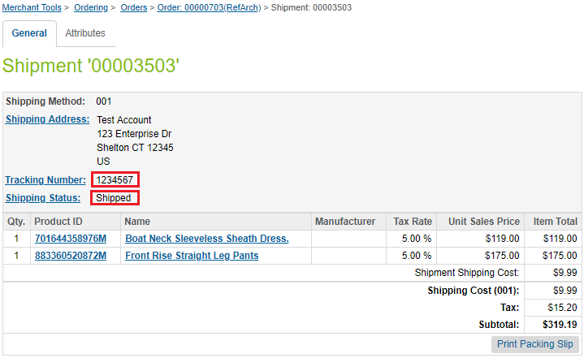
- Navigate to the Notes tab on the order and verify there is a new order note containing the shipment’s tracking information that was entered in Logicbroker.
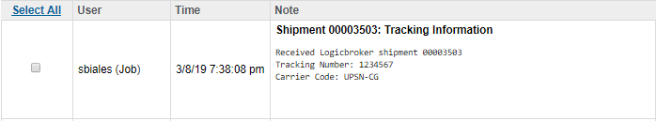

Test Case 10: Pull Shipments (Multiple Ship Addresses, Fully Shipped)
This test will complete the SFCC order from Test Case 9.

Prerequisites:
Complete Test Case 9.

Test steps:
- In the Logicbroker Portal, find the other order associated with the SFCC order you created.
- Create a shipment in Logicbroker for this order and ship all line items, providing a carrier code and tracking number.
- Return to Business Manager and navigate to Administration > Operations > Jobs.
- Run the Logicbroker Pull Shipments job.

Verification:
- In Business Manager, navigate to Merchant Tools > Ordering > Orders and find the order associated with the shipment.
- Verify that the order’s Shipping Status is now “Shipped”.
- Click on the shipment that should have been shipped.
- Verify there is a tracking number which matches the one entered in the Logicbroker system, and that the shipment’s Shipping Status is “Shipped”.
- Navigate to the Notes tab on the order and verify there is a new order note containing the shipment’s tracking information that was entered in Logicbroker.

Test Case 11: Pull Shipments (Multiple Boxes)

Prerequisites:
Create an order with at least 2 line items and export it to Logicbroker.

Test steps:
- In the Logicbroker Portal, find the order associated with the SFCC order you created.
- Create a shipment in Logicbroker for this order and ship the line items in at least two boxes, providing a carrier code and tracking number for each box.
- Return to Business Manager and navigate to Administration > Operations > Jobs.
- Run the Logicbroker Pull Shipments job.

Verification:
- In Business Manager, navigate to Merchant Tools > Ordering > Orders and find the order associated with the shipment.
- Verify that the order’s Shipping Status is now “Shipped”.
- Click on the shipment that should have been shipped.
- Verify there is a tracking number which matches the one of the ones entered in the Logicbroker system, and that the shipment’s Shipping Status is “Shipped”.
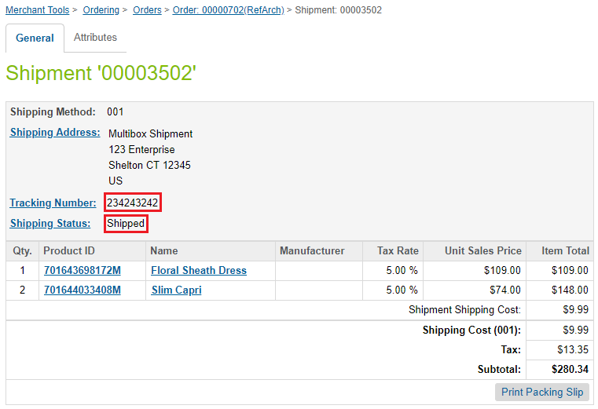
- Navigate to the Notes tab on the order and verify there is a new order note containing the shipment’s tracking information that was entered in Logicbroker for each box.
